

**Mitsubishi FDTC25VF**

**Rs. 127,600/-**

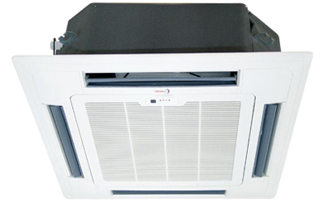

**Product Features**

* precise system control technology
* concealed LED display
* Intelligent airflow
* precise system control technology
* friendly referigerant R410a

**Specification**

**Type** Ceiling Cassette AC

**Cooling (Btu/h)** 48000

**Voltage (V)** 220-240

**Power Input (W)** 6100

**EER (Btu/W-h-W/W)** 8.2-3.45